Session 7

You must trains 3 months, with 2 demo accounts , achieve 80% win rate at all times before going to real accounts

Never analyze positions with anger, or revenge

Always, at all cases and situations, follow the 5 Rules of the strategy to achieve high win rate , if possible follow the other minor rules as wess

Be careful of the Trading Schedule, there could be gaps that pass your SL and you lose a lot of money, dont trade at late fridays, dont trade at early mondays. Follow the best times to trade for each market. Dont enter if spread is more than 2PIPs

Market Range Strategy:

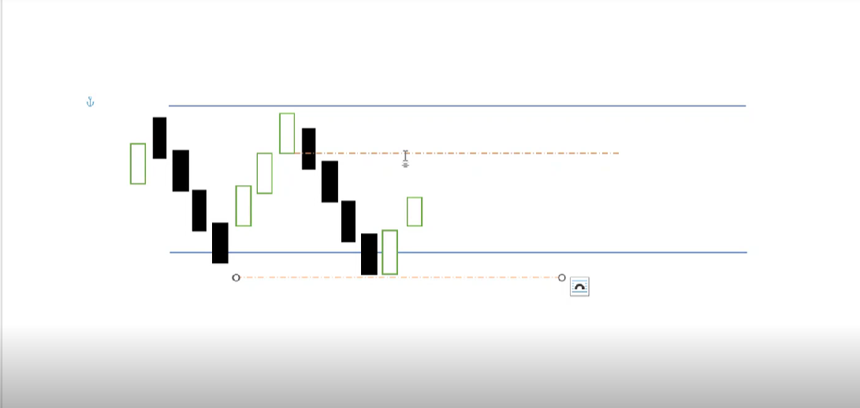

if price tested a line 2 times it becomes valid. So we draw our support and resistance, with the Patterns, we enter trade in the 2nd and 3rd Pullbacks to the lines only. X/Y calculation doesnt work here. But we need a good X to have a 1:1 R2R.

New Strategy:

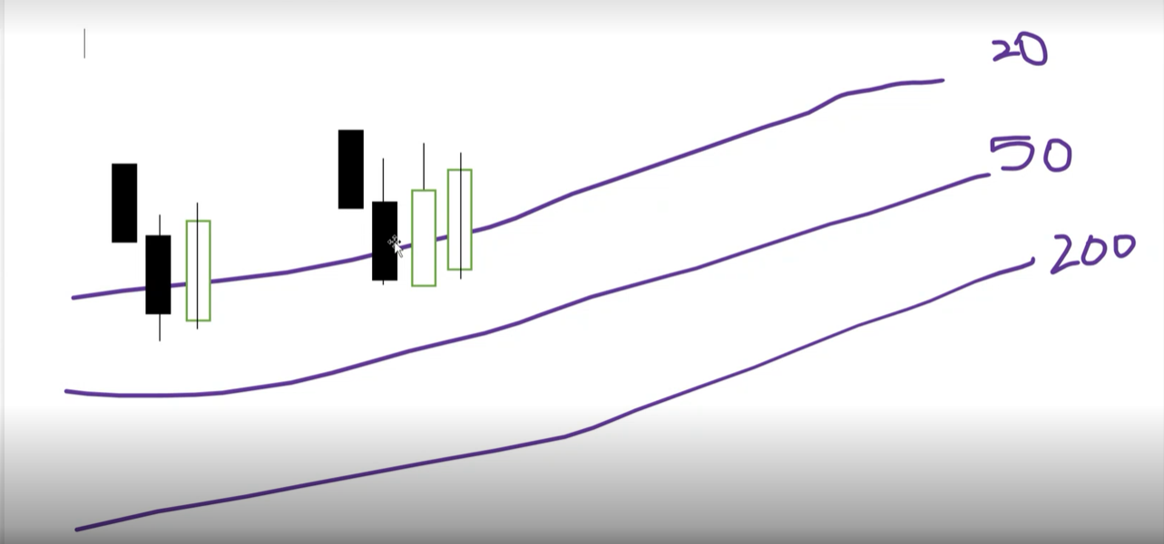

New MAs: 20, 50, 200 (8 should not pass 50)

MA comparison the same, MA increasing values the same (not needed for 200) , MACD increasing as well, RSI validation, HH/LL and HL/LH stays the same. PB count does not matter ( u can enter in the first,2nd,3rd, and 4th)

No patterns needed. Only the next (last closed) candle should have Higher shadows and higher closes (body tops), X calculation stays the same here

Uses two or 3 candle patterns. 2candle pattern should have:

In uptrend, one bearish , one bullish

In downtrend, one bullish one bearish

3candle pattern:

In uptrend, one bearish , two bullish

In downtrend, one bullish two bearish

( in 3 candle patterns, we only apply the higher comparison for the last 2 candles only)